**Ansible**

* Ansible can communicate with nodes by using two approaches
  + adhoc commands:
    - We build a command for desired state
  + playbook:
    - We create a file where we express desired state
    - This is recommended approach for repetitive activites

**Playbook**

* We have taken a sample playbook

---

- name: hello ansible

hosts: all

become: yes

tasks:

- name: update packages and install tree

apt:

name: tree

state: present

update_cache: yes

* We executed playbook  
  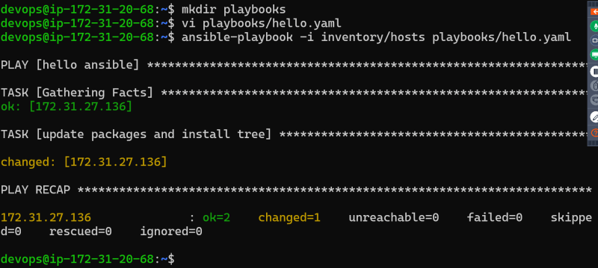
* Basic Playbook semantics  
  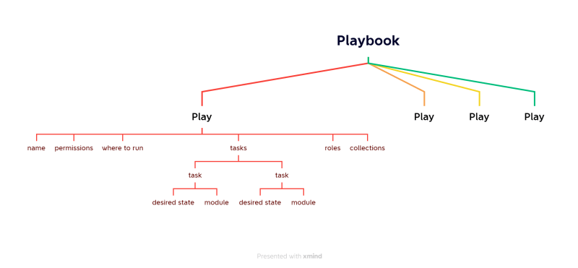
* In ansible the smallest unit of work is perfomed by module

**YAML** > YAML is based on Python**.**

* YAML vs JSON  
  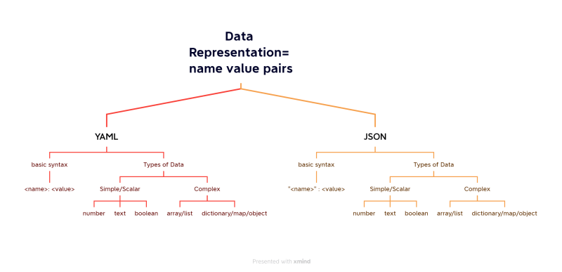
* <https://docs.ansible.com/ansible/latest/reference_appendices/YAMLSyntax.html> for yaml syntax from ansible

**Ways of Working (WoW):**

* list down all the manual steps
* Ensure all the steps are working
* For each step find a module and express the desired state

**Activity 1: Install apache server**

* Manual steps

sudo apt update

sudo apt install apache2 -y

* Verify the installation http://<public-ip>  
  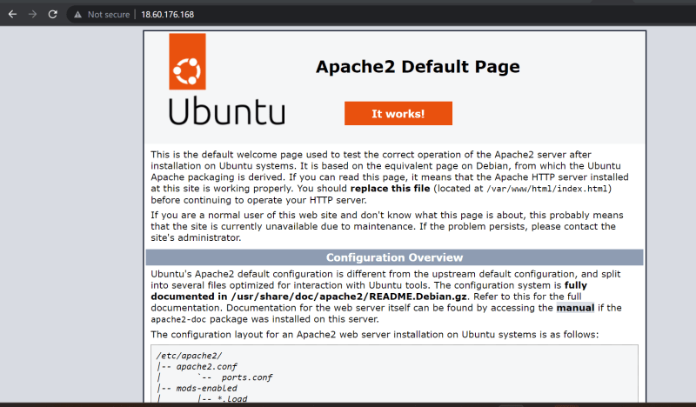
* <https://docs.ansible.com/ansible/latest/playbook_guide/playbooks_intro.html> for ansible yaml syntax for playbook

search google with <command> in ansible  
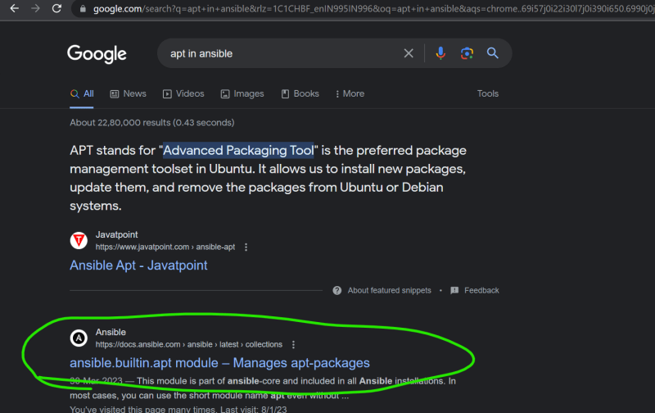

search from ansible docs <https://docs.ansible.com/ansible/2.9/modules/modules_by_category.html>   
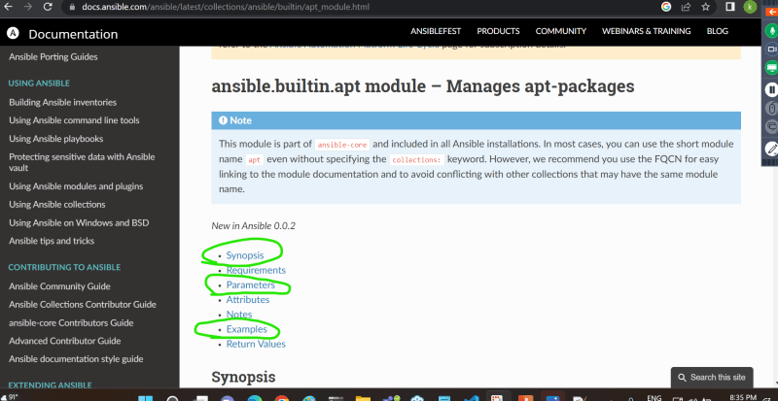

all the commands for installation are executed with sudo

---

- name: install apache server

hosts: all

become: yes

tasks:

- name: install apache

ansible.builtin.apt:

name: apache2

update_cache: yes

state: present

* create inventory

172.31.27.136

* Run the command ansible-playbook -i <inventory-path> <playbook-path>  
  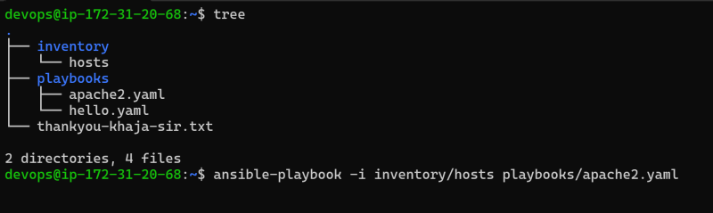
* Execute the playbook  
  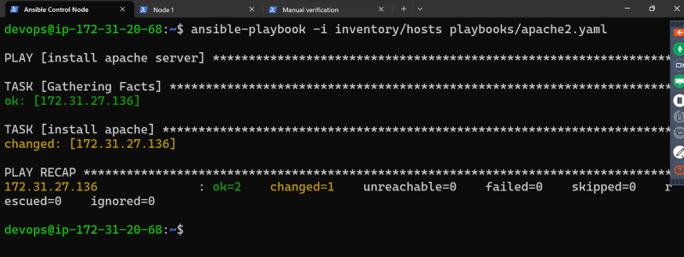
* verify the apache  
  